**Kling, Glöckchen, klingelingeling**

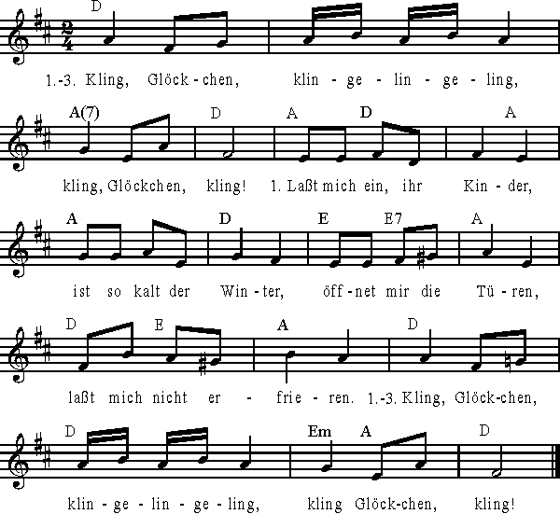

C:\Documents and Settings\installer\Local Settings\Temporary Internet Files\Content.IE5\EUQLY7DG\MC900384230[1].wmf