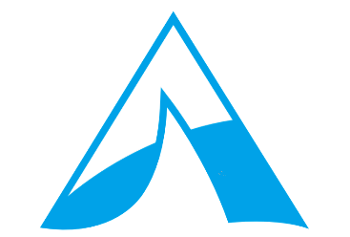 | Photo & Film Policy  German Saturday Schools

With “German Saturday School”, we refer to any of the German Saturday Schools which are part of the German Academy.

From time to time, we publish photos and film taken of students in lessons at The German Academy online, in print media or in our communications.

The German Academy also stores photos and film of students in its web albums. The web albums are password protected, and only parents of current students and students themselves have access to them.

We never publish student names in connection with photos and film material.

Parents (for children under the age of 16) and students can give or withdraw consent for media appearance and the web albums at any time.

Reviewed in May 2019 by
Marianne Siegfried-Brookes
Director

The German Academy
a non-profit company limited by guarantee registered in England and Wales No. 9606717
www.germanacademy.org.uk
office@germanacademy.org.uk

